FOCUS GROUP REPORT ROMANIA

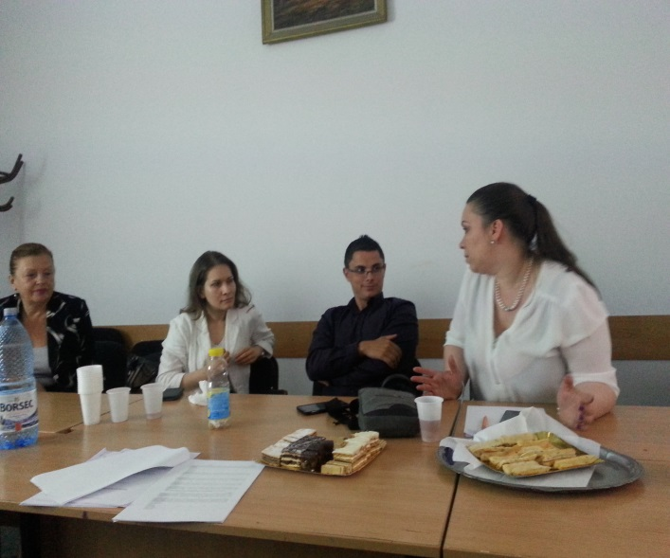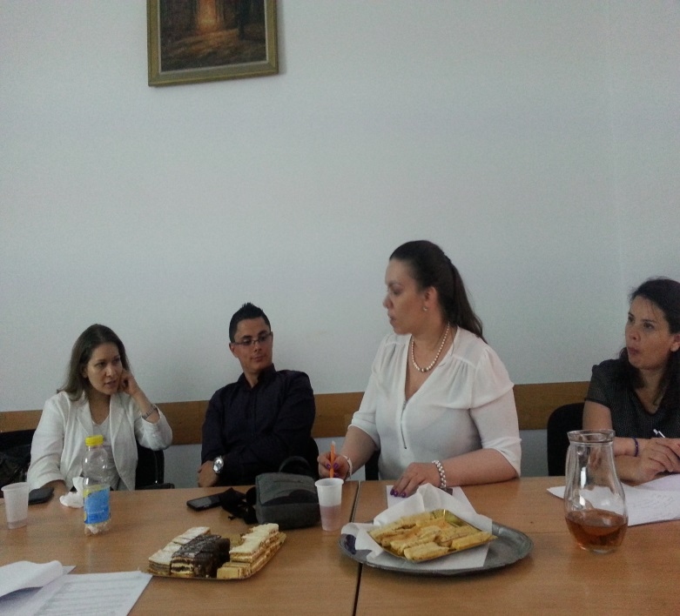

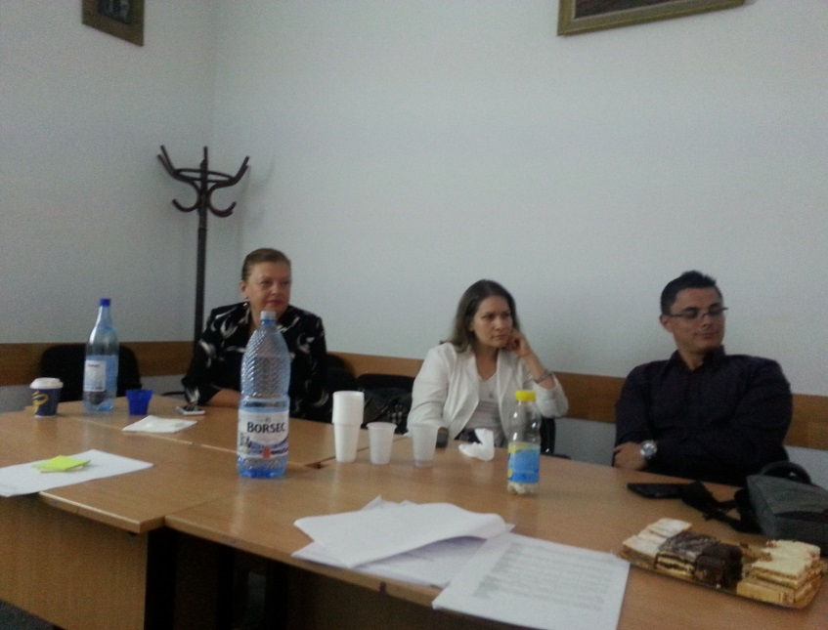

1. INTRODUCTION

In the framework of the ILPO55 project, a focus group was developed on the 19th June 2015 from 6.30 to 8.30pm at ANUP-International . The focus group, was moderated by Ileana Boeru and written by Mina Bauer. Ileana Boeru sent 15 invitations to the Trade Union of Romanian Banks, the Corporate Ownership of the Banks and FSS. From these invitations only 1 person from the ASIROM, insurance company came, and the other 3 persons were filling in questionnaires as front officer, or branch manager, or former branch officer, now in pension.

2. FOCUS GROUP PARTICIPANTS

STAKEHOLDERS | NAME AND SURNAME OF PARTICIPANTS | COMPANY  INSTITUTION | COUNTRY | EMAIL
>55 | Gabriela Alexianu | Former branch manager at BCR , now in pension | Romania | gabriela.alexianu@yahoo.com
<35 | Gruia Diana | ASIROM, biggest insurance company in RO | Romania | diana.gruia@asirom.ro
35-55 | Zanfir Marius | BCR, Central, Front officer SME | Romania | Mariusilie.zanfir@bcr.ro
Banking sector, branch manager | Ruxandra Pavlu | BCR, Bucuresti | Romania | Ruxandraeugenia.pavlu@bcr.ro
5

3. FOCUS GROUP SITUATION

Structure of the Focus Group
The Focus Group consisted of two parts: an introduction and the group discussion.

Introductory Part

- Welcome of participants
- Self-introduction of the moderator and their institution
- Introduction to the ILPO55 project and the aims of the Focus Group
- Information about data protection and asking permission of keeping records/photographs
- Self-introduction of the focus group participants:
  - Profession
  - Institution
  - Expectations on participation in focus group

Focus Group Objectives and key issues:

- Ileana Boeru presented the results of the questionnaire, “competencies” part in order to check, verify the results of the main competencies outlined by the survey:
  - MANAGEMENT SKILLS
  - TECHNICAL SKILLS
  - SOCIAL SKILLS
  - PERSONAL SKILLS
  - INFORMATION AND COMMUNICATION TECHNOLOGIES SKILLS

Due to the big overview that the questionnaire offers, the focus group took most of the time for the prioritisation of the main competencies over 55 and under 35 can offer.
The main findings on the competencies agreed by all the focus groups participants have been:
For the MANAGEMENT SKILLS the first 5 skills represented the highest interest:
- strategic planning and formulation
- strategic implementation
- delegation tasks to teams and individuals
- performance management in terms of planning, conducting, follow up and assessment
These skills are varying as importance in accordance with the working environment. All the components are working together. It is very important that they should be correlated. The correlation should be between back office and front office. This correlation determined the importance of the competences. For back office some of the skills are important , and some other for the front office. The correlation creates a necessary flow in the working process.
For the TECHNICAL SKILLS the discussion refers to the skill of quality and especially how can a <35 individual gave guidance to a >55.
Young employees can accumulate a lot of information, but the individuals of >55 can better manage and structure the information taking into account their working experience. So, the component of quality is not influenced by age.
For the SOCIAL SKILLS there were the most lively discussions. These skills are the most difficult to understand and to transfer for all age groups. We can not speak about an optimal transfer between generations considering their emotional aspect. The >35 individuals can better socialize out of their working time, but even in their free time they still think at their professional profile. There is no time and availability for this categories of personnel.
The most appreciated skills are the following:
- Dialogue and persuasion capacity
- capacity of building sense making
- relationship building and networking
- Team leadership
All the participants agreed on the fact that a good institutional management has to care also about the personal need of the employee in relation with the bank’s objectives. Humans are not only robots focussed only on target accomplishment.
Regarding the assertiveness use of positional power the opinion of all participants is that in Romania we can not speak about a culture of management. At the question of Why?, the answer was that this is due to the former regime which put the employees to execute the orders. There was no space left to have creativity or innovation, but only to do what your boss is telling you to do. “There is also often a mismatch between the orders coming from to many different level managers. One say some, the other sometimes just the contrary, then you as an officer have to ask diplomatically who did tell you to do this or that, in order not to offense them” ( a participant said).
The position of social responsibility facilitator is often linked only to the marketing scope, and the corporation is gaining an image capital.
From the survey one can notice that the employees >55 give guidance more skills to those of <35 than vice versa. The argument is that the young are afraid of losing their jobs if they give guidance to others. They want to preserve their professional acquisitions in terms of competences and skills.

For the PERSONAL SKILLS/BEHAVIOURAL SKILLS.
These skills appear more as demands and not as needs. The charging of the professional profiles is so high that the employees can difficult resist in their job. The profit of the bank is more important that the analysis of the behaviour of the personnel. Therefor the number of personnel >55 becomes smaller and smaller. “We don’t know if the management of the company does really want to maintain these >55 employees, because the management of the company is interested mainly in obtaining results and figures, and to do economy of the resources. They prefer to employ young personnel who do not demand high salaries, as the salaries of >55 employees. In reforms the factor age is important, priority are the <35 who are more exploited” ( said a participant ).
Another interest for the management of the Banks is the under qualified personnel, because their salaries are smaller.
So, that’s why the project has to be grounded in reality, in the sense that these aspects are mismatches that have to be overpassed in order to create good climate for the intergenerational transfer of competence and skills.

4. Identification of interesting practices regarding age management and intergenerational activities in your country
In this respect there are not so much experiences, at least at the level of front office services.
-Ms. Gruia from the ASIROM, the biggest insurance organizationin Romania, is very interested in the implementation of the idea of the project, have some experience in this respect and agreed to come at the focus group, as she wants to implement it in practice.

The level of BCR-Department HR-Training sector-expressed a speical interest for the approach of intergenerational Learning and will inform about this during the European Consultative Seminar of 09/07/2015.
Generally there are quoted some experiences about intergenerational cooperation like : face to face courses, coaching and very few on line courses. There are mentioned also some activities like: win win, Smart start for the beginners. No mentoring activities, no job shadowing at all.
During the Consultative seminar the management level of institutions in charge with training will report on this issue, as it is mentioned as a separate poin on the agenda.
5.Recommendations
The idea of the project is very generous and could help for improving the efficiency of the bank, as a private organisation doing profit, but it is compulsory to build it into the organisation from the top management and taking into account also the human aspects.
This is question of strategy and policy of the bank to build the profit in such a way that this intergenerational learning could be a vector of efficiency.

6.CONCLUSIONS

- The group considers that the intergenerational activities are extremely relevant and could be a useful way to exchange competencies that over 55 have acquired through working experience and, on the other, under 35 have recently learnt from their educational experience.
- Technological abilities are considered as an opportunity to be acquired by over 55 for different purposes: online teaching or mentoring, for instance.
- There are no relevant good practices to be shared as most of them declare that intergenerational activities have not really been implemented in their companies. Some state that over 55 are usually involved in activities such as initial training to new employees but it is not a process that is afterwards sustained during a longer period.

